To Risk Management CISV [Country]

Re: Criminal Record

This letter is regarding the [LEADER/STAFF/JC] [NAME] to be sent as [LEADER of the Danish delegation /STAFF/JC] to the program mentioned below.
Please be informed that we, CISV Denmark, have paid due care to check the background of the [LEADER/STAFF/JC] in the selecting process and have found that this [LEADER/STAFF/JC] has no criminal record. This check is valid for the year of the program mentioned below only.

[LEADER/STAFF/JC]’s name:
Passport number:
Program reference:
Program location:
Period:
Date of criminal record check:

Best regards, Rikke Juel Enemærke
Date:
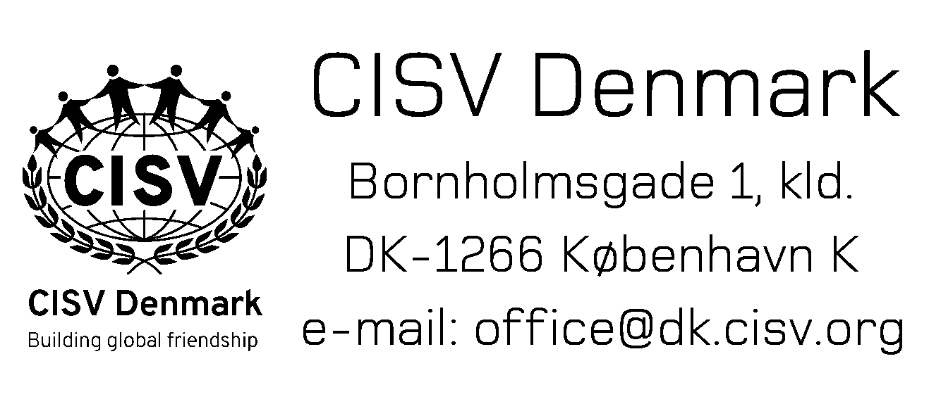
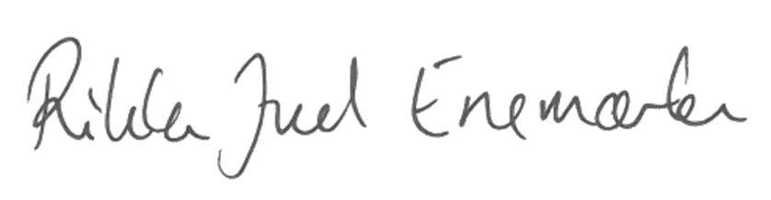

Rikke Juel Enemærke
President
president@dk.cisv.org, +4526740263

To Risk Management CISV Denmark

Re: Criminal Record

This letter is regarding the [LEADER/STAFF/JC] [NAME] to be sent as [LEADER of the [COUNTRY] delegation /STAFF/JC] [NAME] to the program mentioned below.
By submitting and returning this form I assure CISV Denmark, that our National Risk Management in CISV [COUNTRY], have paid due care to check the background of the [LEADER/STAFF/JC] in the selecting process and have found that this [LEADER/STAFF/JC] has no criminal record. This check is valid for the year of the program mentioned below only.

[LEADER/STAFF/JC]’s name:
Passport number:
Program reference:
Program location:
Period:
Date of criminal record check:

Best regards, [NAME]
Date:

[NAME]
[Position]
[mail@xx].cisv.org, [+phone]

