Copenhagen, 2022-02-18

Official delegation invitation letter for Youth Meeting Programme

  - Camp address: , Denmark

Dear Sir/Madame,
I’m delighted to send a formal invitation to the CISV delegation from NATION participating in the Youth Meeting programme held in LOKALFORENING, Denmark from DDth July to DDrd August 20YY.
Youth Meetings CISV’s Youth Meeting programme encourages young people to take a leading role in planning and organizing activities. The participants and their adult staff use CISV’s peace education to guide the theme of the camp around which they plan activitie. Youth Meetings bring small groups of young people, of similar ages together from different countries within a region. Youth Meetings are for 25-35 participants aged 12-13 / 14-15 / 16-18 / 19+ from 5-20 nations. The camp is planned and run by adult staff with the participants. Young people aged under 16 travel in delegations accompanied by an adult leader.
Taking part in a Youth Meeting helps participants explore aspects of a theme that affects us all such as identity, democracy, or environmental protection, and share perspectives and learn from each other. Participants can use the gain from the experience – new understanding and planning and communication skills – beyond the camp during school, college, or community.
CISV Denmark and chapter CISV LOKALFORENING will be helpful with the whole arrangement. All the costs of the delegation during their stay in Denmark will be covered by CISV Denmark, so the different participants will not have the necessity of paying anything during their stay in Denmark.

The participant from NATION is:
Name | Sex | Date of Birth | Passport ID | Date of Expiry

ELLER
The NATION participants are:
 | Name | Sex | Date of Birth | Passport ID | Date of Expiry
Adult Leader
Child Delegate

Best regards, Rikke Juel Enemærke
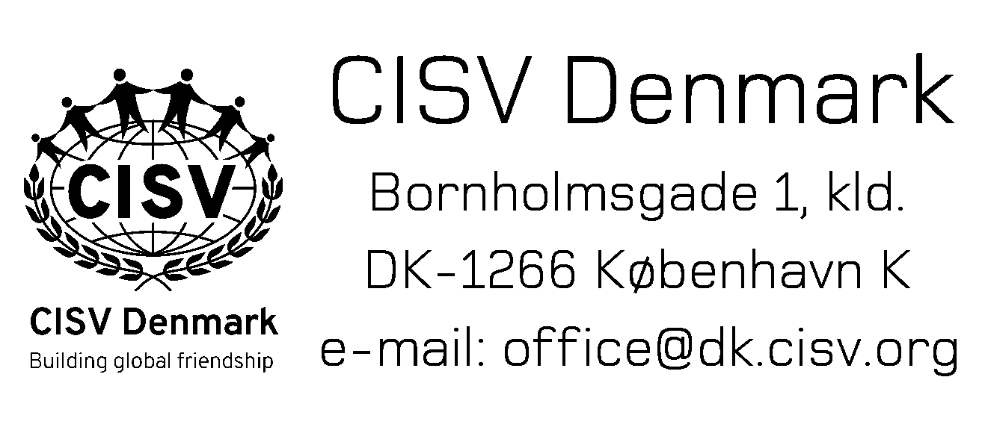
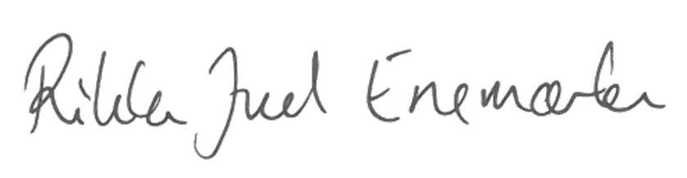

Rikke Juel Enemærke
President, CISV Denmark
president@dk.cisv.org, +4526740263

