Copenhagen, 2022-02-18

Official delegation invitation letter for Village Programme

  - Camp address: , Denmark

Dear Sir/Madame,
I’m delighted to send a formal invitation to the CISV delegation from NATION participating in the Village program held in LOKALFORENING, Denmark from DDth July to DDrd August 20YY.
CISV Villages are international camps that bring 11 years old’s together to learn from each other and the world around them. The children come together from many different countries to take part in a variety of educational, cultural, and fun activities. Each Village welcomes delegations from 12 countries. Each delegation has two boys and two girls, accompanied by an adult leader. The camp is coordinated by adult staff, supported by Junior Counsellors (age 16-17).
A Village creates a safe, fun setting in which the children will learn, with children from around the world, about each other’s lives and cultures and how to communicate, cooperate, and live together. The Village learning experience, and the friendships they make, will last the children a lifetime.
CISV Denmark and chapter CISV LOKALFORENING will be helpful with the whole arrangement lasting from the DDth July until the DDnd August 20YY. All the costs of the delegation during their stay in Denmark will be covered by CISV Denmark, so the different participants will not have the necessity of paying anything during their stay in Denmark.

The [NATION] participants are:
 | Name | Sex | Date of Birth | Passport ID | Date of Expiry
Adult Leader
Child Delegate

Best regards, Rikke Juel Enemærke
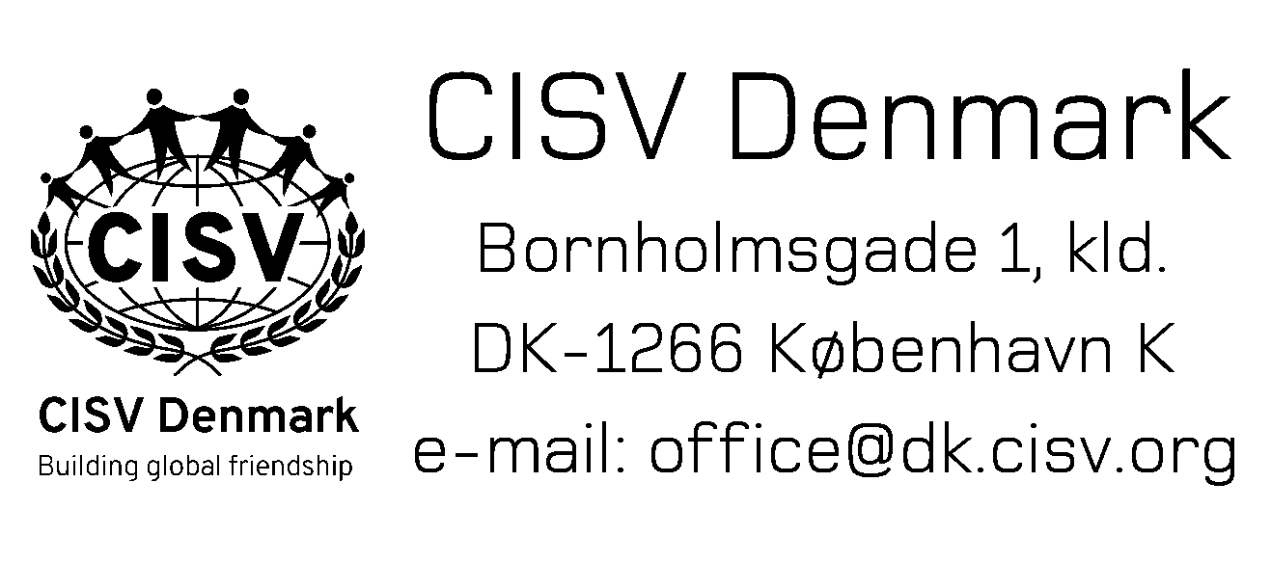
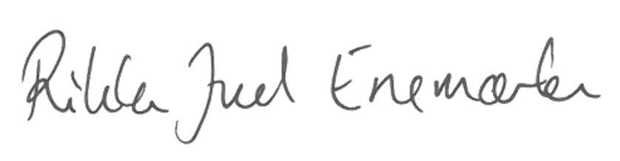

Rikke Juel Enemærke
President, CISV Denmark
president@dk.cisv.org, +4526740263

