Copenhagen, 2022-02-18

Official delegation invitation letter for Step Up Program

  - Camp address: , Denmark

Dear Sir/Madame,
I’m delighted to send a formal invitation to the CISV delegation from NATION participating in the Step Up programme held in LOKALFORENING, Denmark in July 20XX:
CISV’s Step Up programme encourages young people to take a leading role in planning and organizing activities. The participants and their adult leaders use CISV’s peace education to guide the theme of the camp around which they plan activities, such as identity, democracy, or environmental protection. Step Up delegations come from nine countries and are comprised of four young people, 2 girls and 2 boys, who are accompanied by an adult leader. The camp is planned and run by adult staff with the participants.
Taking part in Step Up gives you the amazing opportunity to learn about important issues that affect us all and how they are thought about and dealt with in different countries and cultures. You will think about how to take your new knowledge and leadership skills and make active use of them in your school or community. Just as importantly, you will have fun and make new and lasting friendships.
CISV Denmark and chapter CISV LOKALFORENING will be helpful with the whole arrangement lasting from the DDth July until the DDst July 20YY. All the costs of the delegation during their stay in Denmark will be covered by CISV Denmark, so the different participants will not have the necessity of paying anything during their stay in Denmark.

The NATION participants are:
 | Name | Sex | Date of Birth | Passport ID | Date of Expiry
Adult Leader
Child Delegate

Best regards, Rikke Juel Enemærke
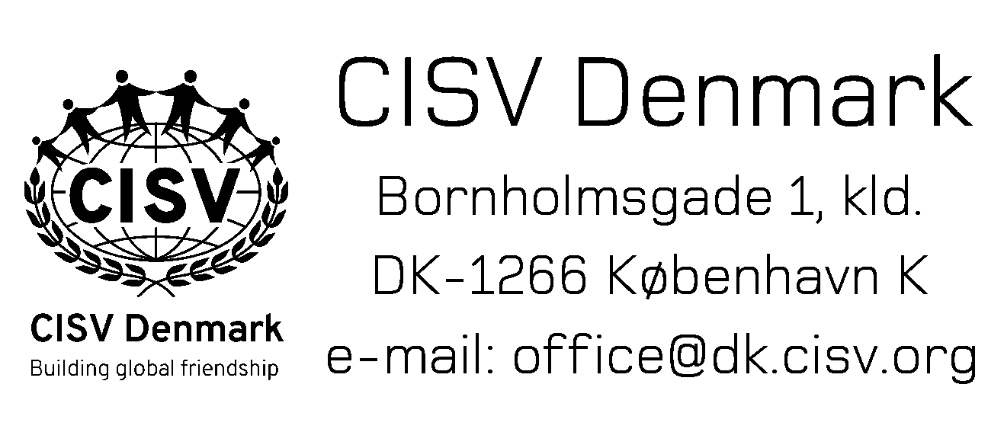
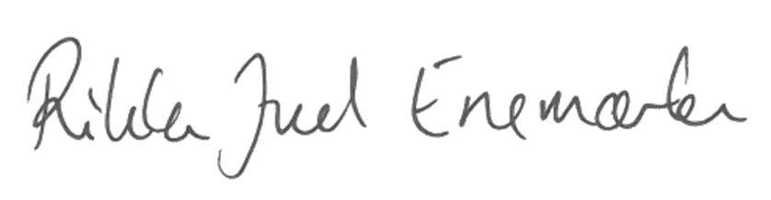

Rikke Juel Enemærke
President, CISV Denmark
president@dk.cisv.org, +4526740263

