Copenhagen, 2022-02-18

Official participation invitation letter for Seminar Camp Programme

  - Camp address: , Denmark

Dear Sir/Madame,
I’m delighted to send a formal invitation to the CISV participant from Brazil participating in the Seminar Camp programme held in LOKALFORENING, Denmark from DDth July to DDrd August 20YY.
CISV’s Seminar Camp programme is a challenging, intensive programme coordinated by the young participants. They develop their own agenda and explore global issues based on their backgrounds and interests through activities and in-depth discussions. Seminar Camps are for 30 international participants, with the supervision and assistance of international adult staff.
Joining a Seminar Camp puts you in the driving-seat, planning and leading the programme with fellow participants. Being part of Seminar Camp’s group-living environment encourages you to take a creative and cooperative approach to problem-solving and resolving differences that can arise from healthy discussion. Friendship and fun ensure that your Seminar Camp experience is lasting and positive.
CISV Denmark and chapter CISV LOKALFORENING will be helpful with the whole arrangement. All the costs of the delegation during their stay in Denmark will be covered by CISV Denmark, so the different participants will not have the necessity of paying anything during their stay in Denmark.
The participant from NATION is:
Name | Sex | Date of Birth | Passport ID | Date of Expiry

Best regards, Rikke Juel Enemærke
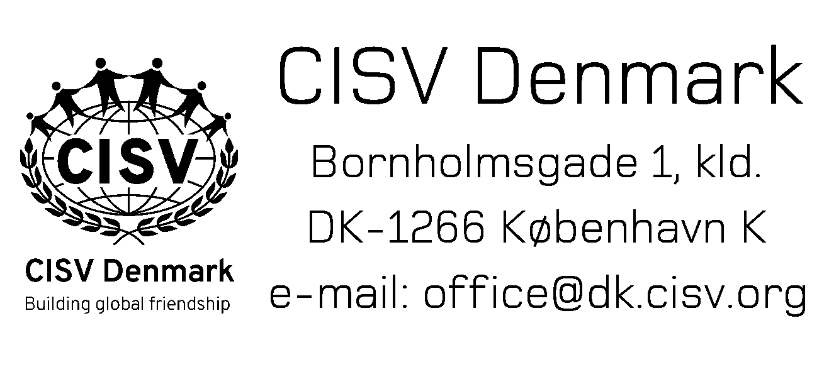
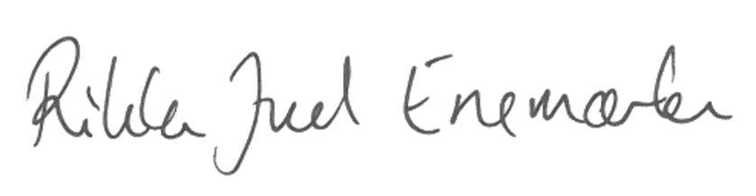

Rikke Juel Enemærke
President, CISV Denmark
president@dk.cisv.org, +4526740263

